<https://www.ramotion.com/blog/web-design-interview-questions/>

[Web Design](https://www.ramotion.com/blog/tag/web-design/)

**Web Designer Interview Questions and Answers - 2023**

A web designer interview is filled with numerous tricky questions. Though do not worry. We have got all the answers to help you land the desired job.

Written by **[Ramotion](https://www.ramotion.com/blog/author/ramotion/)**Oct 27, 202011 min read

**Table of Contents**

1. [How to Make a Powerful Impression in Web Design Job Interview](https://www.ramotion.com/blog/web-design-interview-questions/#section-how-to-make-a-powerful-impression-in-web-design-job-interview-tips-and-tricks)
2. [Why do you want to be a web designer?](https://www.ramotion.com/blog/web-design-interview-questions/#section-question-why-do-you-want-to-be-a-web-designer)
3. [How do you handle the pressure?](https://www.ramotion.com/blog/web-design-interview-questions/#section-question-how-do-you-handle-the-pressure)
4. [What is your working style?](https://www.ramotion.com/blog/web-design-interview-questions/#section-question-what-is-your-working-style)
5. [What sources do you follow and read regularly?](https://www.ramotion.com/blog/web-design-interview-questions/#section-question-what-sources-do-you-follow-and-read-regularly)
6. [What programs do you use?](https://www.ramotion.com/blog/web-design-interview-questions/#section-question-what-programs-do-you-use)
7. [What is CSS and its purpose?](https://www.ramotion.com/blog/web-design-interview-questions/#section-question-what-is-css-and-its-purpose)
8. [Is CSS case sensitive?](https://www.ramotion.com/blog/web-design-interview-questions/#section-question-is-css-case-sensitive)
9. [Why should you use CSS float?](https://www.ramotion.com/blog/web-design-interview-questions/#section-question-why-should-you-use-css-float)
10. [What is Flexbox?](https://www.ramotion.com/blog/web-design-interview-questions/#section-question-what-is-flexbox)
11. [What is HTML5?](https://www.ramotion.com/blog/web-design-interview-questions/#section-question-what-is-html5)
12. [What have been your key responsibilities as a web designer?](https://www.ramotion.com/blog/web-design-interview-questions/#section-what-have-been-your-key-responsibilities-as-a-web-designer)
13. [How you deal with harsh criticism from a client?](https://www.ramotion.com/blog/web-design-interview-questions/#section-question-how-you-deal-with-harsh-criticism-from-a-client)
14. [What are the first questions you ask a client?](https://www.ramotion.com/blog/web-design-interview-questions/#section-question-what-are-the-first-questions-you-ask-a-client)
15. [Do you have any experience with UX design?](https://www.ramotion.com/blog/web-design-interview-questions/#section-question-do-you-have-any-experience-with-ux-design)
16. [What is trendy these days?](https://www.ramotion.com/blog/web-design-interview-questions/#section-question-what-is-trendy-these-days)
17. [What are some bad examples of web design?](https://www.ramotion.com/blog/web-design-interview-questions/#section-question-what-are-some-bad-examples-of-web-design)
18. [What is an optimized website? How you create one?](https://www.ramotion.com/blog/web-design-interview-questions/#section-question-what-is-an-optimized-website-how-you-create-one)
19. [What makes a good color scheme?](https://www.ramotion.com/blog/web-design-interview-questions/#section-question-what-makes-a-good-color-scheme)
20. [Conclusion](https://www.ramotion.com/blog/web-design-interview-questions/#section-conclusion)

**Last Updated: December 27, 2021**

They say you have just 7 seconds to make the first impression. And when it comes to job interviews in [website design companies](https://www.ramotion.com/web-design/), where [competition is cut-throat](https://www.ramotion.com/blog/competitive-analysis-in-ux-design/), you have only one chance to make it count. The sad truth is, with website agencies, you have just one shot. Everything should be flawless from the start to the end.

Sound like a mission impossible? No pressure, whatsoever, because we have got you covered.

Follow our list of the best tips and tricks to create a convincing impression as well as familiarize yourself with the popular web design interview questions (answers are included) to land the desired web designer job.

**How to Make a Powerful Impression in Web Design Job Interview**

To make a powerful impression in the web design interview, you need to be with your guns loaded. You should look great, exude confidence, and of course, know all the answers to web design interview questions.

Therefore, to successfully get your foot in the door at a [web design agency](https://www.ramotion.com/web-design/), you need to sweat your guts out beforehand. And we will give you some directions with the best tips and tricks.

* Carry out detailed research of the company. Define its mission, policy, pros, and cons.
* Come prepared to discuss your salary expectations. Visit a salary calculator. Based on your experience, industry, and location, it will give you a hint on what to ask for.
* Underlie the skills that the employer calls for. Even though you are preparing for a web designer position, there can still be some specific requirements.
* Review projects you have worked on. What were the best and the worst one websites? What did you learn from them? How did you cope with the failure?
* Review terminology. Be ready to face questions with specific terms.
* Use the STAR method to nail behavioral web design interviews. STAR stands for Situation Task Action Result. This method helps to create a storytelling structure that is very easy to follow. Use it to shed light on your experience and abilities to solve the problems.
* Try to be concise and straight to the point. The rule of thumb, you have just 2 minutes for each question.
* Try to maintain positive body language.
* Prepare your web designer questions and answers beforehand and practice them by saying out loud. You may even ask a friend to play the role of interviewer.
* Last but not least, prepare questions for the employer. Show your serious intention to get this job by asking about day-to-day responsibilities, challenges that you are going to face, how your performance will be measured, and how people typically collaborate inside the team, department, and company.

**Web Designer Interview Questions**

1. Why do you want to be a web designer?
2. How do you handle the pressure?
3. What is your working style?
4. What sources do you follow and read regularly?
5. What programs do you use?
6. What is CSS and its purpose?
7. Is CSS case sensitive?
8. Why should you use CSS float?
9. What is Flexbox?
10. What is HTML5?
11. What have been your key responsibilities as a web designer?
12. How you deal with harsh criticism from a client?
13. What are the first questions you ask a client?
14. Do you have any experience with UX design?
15. What is trendy these days?
16. What are some bad examples of web design?
17. What is an optimized website? How you create one?
18. What makes a good color scheme?

web design interview questions

There is no job interview without questions, therefore be ready to face them. Depending on the company, they may vary. Nevertheless, there are still some popular options. Let’s consider them along with the answers and hints.

**Why do you want to be a web designer?**

Prepare a list of reasons why you are passionate about this job. You can tell a story or just be constructive. Everything works as long as it shows your true love for the occupation.

**How do you handle the pressure?**

This is one of the top web designer interview questions.

We are living in a high-pressure society where problems occur all the time: the client does not like your work, tight deadline, the developer is unable to realize your idea, etc. Therefore, the ability to handle such situations is crucial for a web designer.

Tell the interviewer what techniques do you use to deal with pressure. Use real-life examples to prove their validity.

**What is your working style?**

Tell your interviewer not only your web design routine but also how you communicate with others. After all, web designers can’t exist in a vacuum. Every project - whatever small or big - requires well-coordinated work of the entire team.

So, are you a team player? Prove this to your potential employer by telling him or her that you are open to revisions and comfortable with adapting. Focus on your collaboration and communication skills

**What sources do you follow and read regularly?**

As a web designer who shoot for the stars, it is obliged to stay on top of things. Therefore, impress your interviewer with websites that you visit regularly. Do not be afraid to tell the actual names.

Everyone knows that Smashing Magazine is one of the top online magazines for web designers, whereas Ramotion web design agency is a great source of free high-quality assets. Also mention where do you get your dose of website inspiration.

It is vital to make the impression that you follow the trends, use products that meet current requirements and make the most out of pioneering tricks.

Enough of web design questions and answers concerning your [persona](https://www.ramotion.com/blog/ux-personas/) and experience. It is time to get to the questions and answers that reveal your actual web designer skills.

**What programs do you use?**

Show your intellectual horizon by listing the most popular tools of the trade, such as Photoshop, Sketch, Figma, Illustrator. You may even impress interviewers with your observations. What platforms are handy to use? What are the cons and pros? In the end, focus on one that you prefer the most.

web design code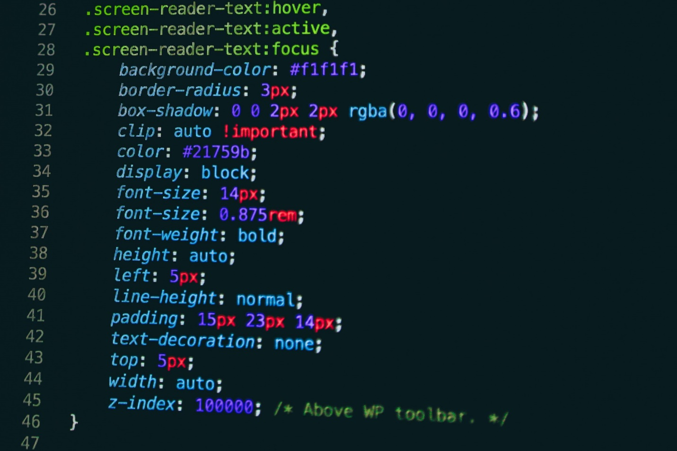

Related Posts: [Web Development Interview Questions](https://www.ramotion.com/blog/web-developer-interview-questions/), [UX Design Interview Questions](https://www.ramotion.com/blog/ux-interview-questions/), [Startup Interview Questions](https://www.ramotion.com/blog/startup-interview-questions/),

**What is CSS and its purpose?**

Even though CSS is not a prime concern of a web designer, you should still know about it. Therefore, re-read manuals and documentation.

On top of that, you should also be ready to answer some tricky questions. For example,

**Is CSS case sensitive?**

CSS is not case sensitive. However, some elements, like font families or direct references, might be case sensitive.

**Why should you use CSS float?**

Float is used for positioning. It can float images or blocks to the right or left side of the container. It is the primary solution to wrap text around images.

**What is Flexbox?**

Flexbox is a flexible layout. It is used to position elements and distribute space inside the container. It comes in handy when you need to create a responsive web design.

laptop with code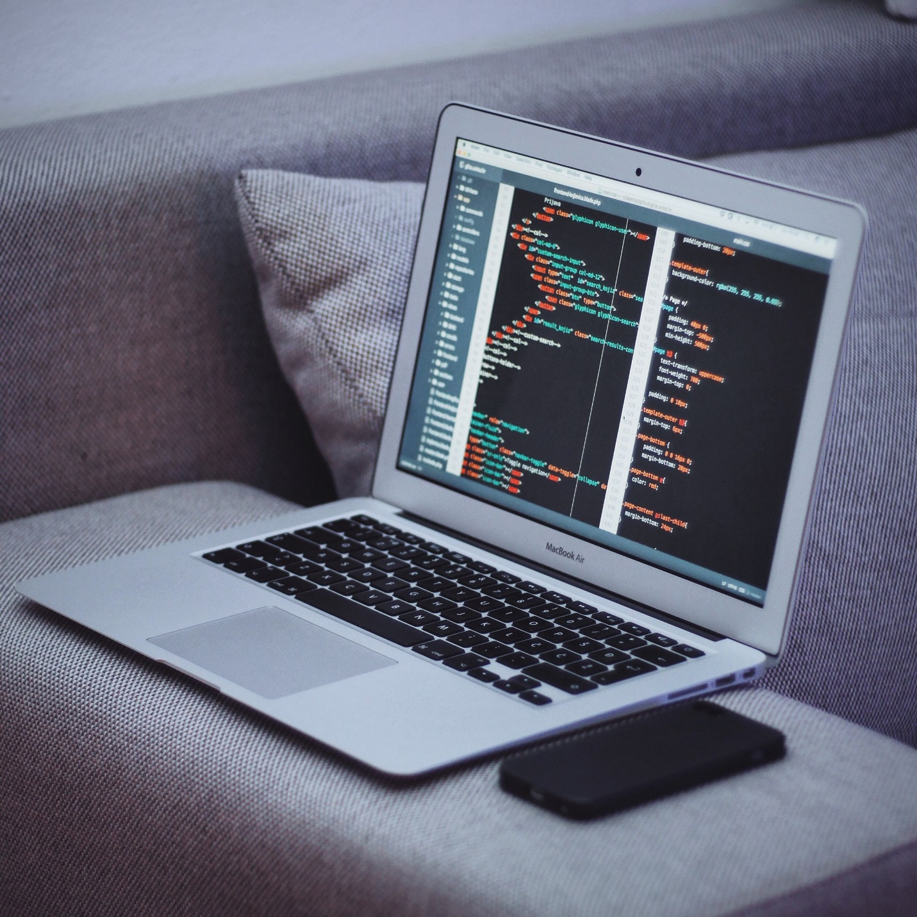

**What is HTML5?**

HTML5 is the current version of HTML (Hypertext Markup Language). It is used to form the structure of the web page.

Again, you do not have to know it inside out, since as a web designer, it is not your responsibility. However, still, you should know the basics. Therefore, visit such helpful websites as [w3schools](https://www.w3schools.com/TAGS/default.ASP) or [GeekforGeeks](https://www.geeksforgeeks.org/), where this topic is thoroughly discussed. Meanwhile

**What have been your key responsibilities as a web designer?**

It is an excellent opportunity to brag about your organizational skills and a chance to prove interviewer that you are a trusted asset. Even though you are a creative creature, you are still no alien to rules and responsibilities so that the teammates and your employer can rely on you.

Tell about your roles in previous projects and how you have handled them. If they helped increase your knowledge or master your skills, then it is a perfect time to mention this.

**How you deal with harsh criticism from a client?**

Not a single interview goes by without this question. Every employer wants to know how you can deal with criticism since artists take signs of disapproval of their work personally. As for clients, sometimes they can be highly opinionated, but you still need to work with them.

It is here where you need to show your communication techniques. Good web designer never resists making changes to their work. In fact, professional designers always appreciate constructive feedback and can efficiently deal with criticism since it helps them grow.

Every employer wants a web designer who can reach a consensus with the clients and quickly adapt the design to new demands. Tell your interviewer about a time you received harsh criticism but managed to find compromise leaving everyone happy.

**What are the first questions you ask a client?**

Sometimes this question may sound like “What is your first step?” Your interviewer wants to know whether you dive into work right away or give some thoughts to the project.

It is vital to prove to your potential employer that you do not make any assumptions since they can be misleading. A good web designer will conduct thorough [research on the task](https://www.ramotion.com/blog/what-is-ux-research/), prepare a list of questions and attentively listen to a client.

**Do you have any experience with UX design?**

Hyper-personalized experience is our future. Although it is a prerogative of UX specialists, still web designer plays a crucial role in bringing UX solutions to life. You are obliged to know the basics of good user experience and apply them in the projects. Therefore, you need to feel comfortable discussing this issue.

Even if you have never dealt with this field, you can still impress your interview with basic knowledge of the topic and some good tips recommended by the UX gurus. On top of that, you can mention how you can implement research findings into your designs if you have an opportunity to work with a UX designer.

If you have already realized [UX design](https://www.ramotion.com/ui-ux-design/), tell your interviewer the crucial points and takeaways of the previous experience. It will not hurt to show the real examples as well.

More questions about UX Design you can read here.

**What is trendy these days?**

Sometimes this question may sound like, “Do you follow current mainstreams?” This is a test of your industry knowledge. Whatever attitude you have towards the current mainstreams, the answer to this question should always be “Yes.” No one wants to deal with a person who prays old-fashioned ways. Companies want to look and feel fresh on the web. You need to stay on top of things, even if you are a novice. Therefore, do your homework and gather some information about new trends.

It is also essential to not just list them blindly but also know their flaws and caveats. Tell your interviewer what you think is the most exciting trend and how you plan to realize it. Also, share a list of your favorite sites, Behance profiles, or Pinterest accounts where you get inspiration.

**What are some bad examples of web design?**

Although we are up to only good web design, however, it is crucial to know some bad examples and [poor practices to avoid them at any cost](https://www.ramotion.com/blog/bad-websites/).

On top of that, this question is an excellent chance for your potential employer to get what you think is bad design so that he or she can understand whether you fit their company’s ideology.

If you want to play safe, you can list these elements as bad practices:

* blinking and flashing images;
* poor contrast between the background and the foreground elements;
* a poor balance between visual and textual data;
* too much color;
* typography mistakes like poor kerning or tiny fonts;
* poorly optimized images;
* absence of informational hierarchy;
* inconsistent styles.

Finally, always remember the three pillars of good website design: responsiveness, mobile-friendliness, and [accessibility](https://www.ramotion.com/blog/wcag-meaning/). If one of these criteria has not been met, then the website can be considered bad, regardless of its impressive hero area or outstanding design features.

**What is an optimized website? How you create one?**

Although web developer is responsible for the most work with optimization, web designer performs the vital role here as well.

The potential employer wants a candidate who fully understands the importance of optimization and knows basic principles.

Therefore, familiarize yourself with the essentials and list the key points. Name a few easy ways to optimize a website. If you are short of solutions, you can go for such good practices as:

* Optimize images to reduce loading times.
* Compress all graphical assets and save them in the appropriate format.
* Create only necessary images to ensure the responsive side of the project does not slow down the website.
* Minimize CSS files.
* Choose the best solutions for implementing mobile friendliness.
* Limit the number of fonts and load only the required ones.

To get some extra points, support each optimization method with some real examples.

**What makes a good color scheme?**

Color is the first thing that people notice and understand in web design; therefore, it is one of the most crucial elements. As a web designer, you should know the ins and outs of [color theory](https://www.ramotion.com/blog/website-color-schemes/), so this question is another test of industry knowledge where you need to impress.

Although there is no universal answer to a good color scheme since every project requires its unique approach, there are still some good practices that ensure the color scheme is harmonious and eye-pleasing.

Mention basic principles of color theory, underlie good solutions, and prove to your interviewer that you always keep an eye to detail when combining hues to show your expertise in this field.

**Conclusion**

Preparing for a job interview is a job. You should take it seriously. Therefore, do your homework. Along with popular web design and web developer interview questions, find all possible traps. Write down answers and practice them out loud. Keep track of things that are going on in the web design world. And remember, you are the best candidate they may ever have, therefore act like one.

Updated: Apr 4, 2023